Project

Advanced Lane Detection

Author

Medhat HUSSAIN

Version 1.0

Inhalt

Objective 3

Folder structure 3

File Architecture 3

Steps (pipeline): 4

Configuration 4

How to invoke the test? 4

Results &Conclusions 5

Challenges and improvements 5

Output samples 6

images 6

project_video 8

challenge_video 11

harder_challenge_video 13

# Objective

Building a lane detection module able to come-over the lighting change and independent from the colors.

Prerequisite:

Camera is mounted in the middle of the car and there is no lane change.

# Folder structure

Output images are saved under “output_images”. Within such folder you can find several subfolders to contain the output from different processing stages.

Output videos are saved under “test_videos_output”.

# File Architecture

Master.py: is the entry point where the test can be invoked.

common.py: to contain all common functionalities

test_images.py: test images module

test_videos.py: test videos module

configuration.py: contains some configuration parameters

color.py: contains some color filters functionalities

calibration.py: contains all calibration functionalities

sobel.py: contains sobel gradient filters

line.py: contains line/lane search functionalities

# Steps (pipeline):

1. Undistorting the image
2. Get different colors and gradient components from image.
3. Form the combined image.
4. Get the unwrapped version “perspective transform”.
5. Search for the lane lines “sliding window”.
6. Measure the curvature.
7. Measure the offset.
8. Project the detected lanes area to the original image.

Calibration is done only once and loaded once per run.

# Configuration

All high level parameters under the file configuration.py, below some of them.

|  |  |  |
| --- | --- | --- |
| Name | Value Example | description |
| DEBUG | 0 | Activated only for the debug mode, extra images will be generated. |
| TEST_MODE | ("VIDEO", "A") | Determine which test to run, for example video or image test. |
| USE_PROFILER | TRUE | Invoke the profiler as well to analysis the time consumption |
| USE_THREADING | False | Activate the multithreading capability (for image processing) |
| SHORT_SCAN | True | Scan only for short range lane |

# How to invoke the test?

Simply invoke the Master script “python Master.py”, it will start processing for the project video, or you may also invoke the document “run.ipynb”

Hint:

The configurations are adjusted for the project video, for the challenges one, you need to activate the short scan mode, in the configuration.py it should be “SHORT_SCAN = True”

# Results &Conclusions

For the project video, the results look fine nevertheless for the challenging only about 60% is acceptable.

# Challenges and improvements

Challenges

* Hard curves are not well handled “Lanes are almost horizontal”
* Road edges are recognized as a lane line.
* One Frame processing time is about 0.5 seconds, so challenging for the online processing which have about 30 f/s 🡪 only 33 ms (core i7 2.3 GHz)

Improvements

* We should have a variable perspective transform “source points”, to come over the sharp curves.
* Colors’ filters should be involved more, process only the white and yellow lines.
* We should have some clear criteria, to judge if the detected lanes are reliable or we should count on the historical data.
* We should be able to isolate the background from the road (region of interest).

# Output samples

## images

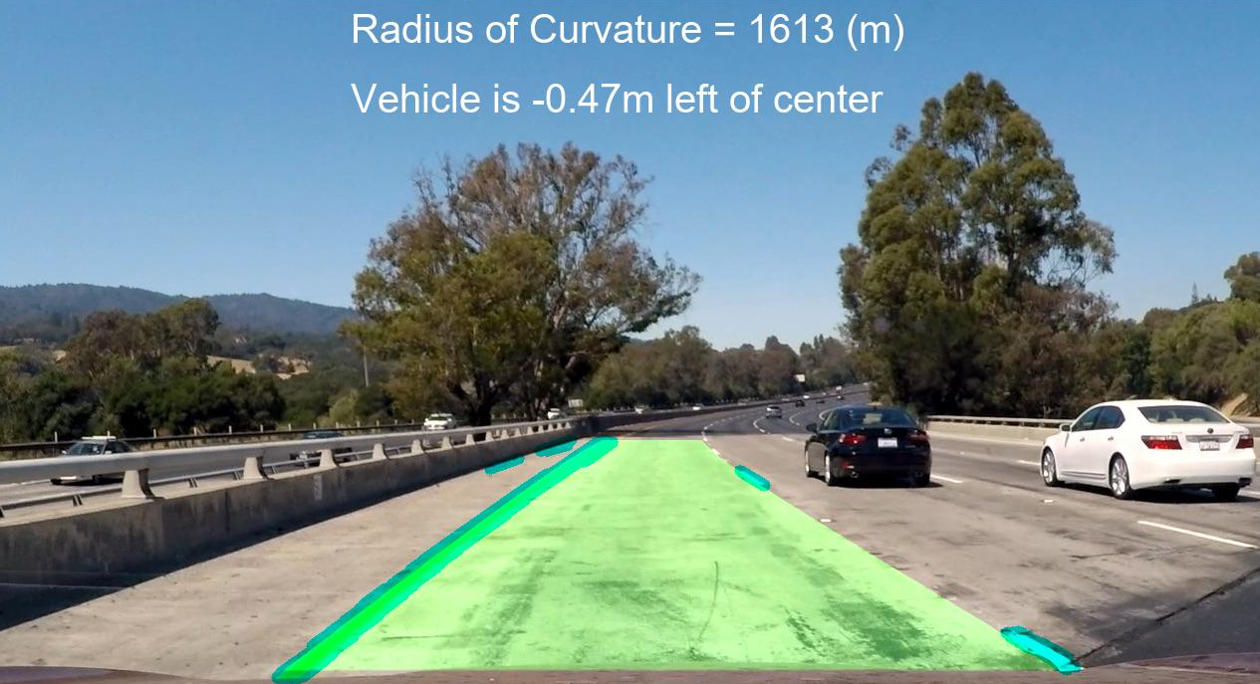

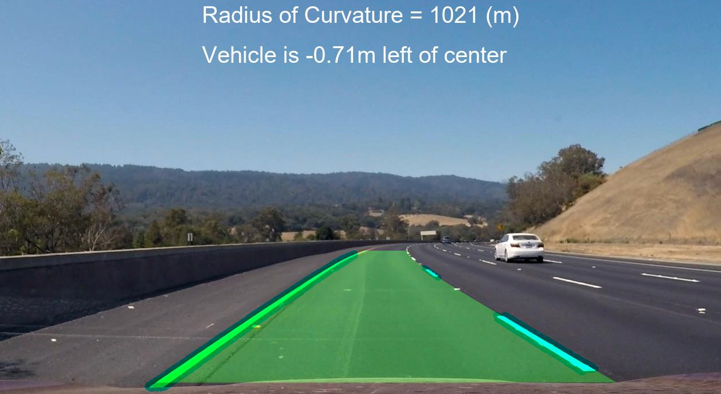

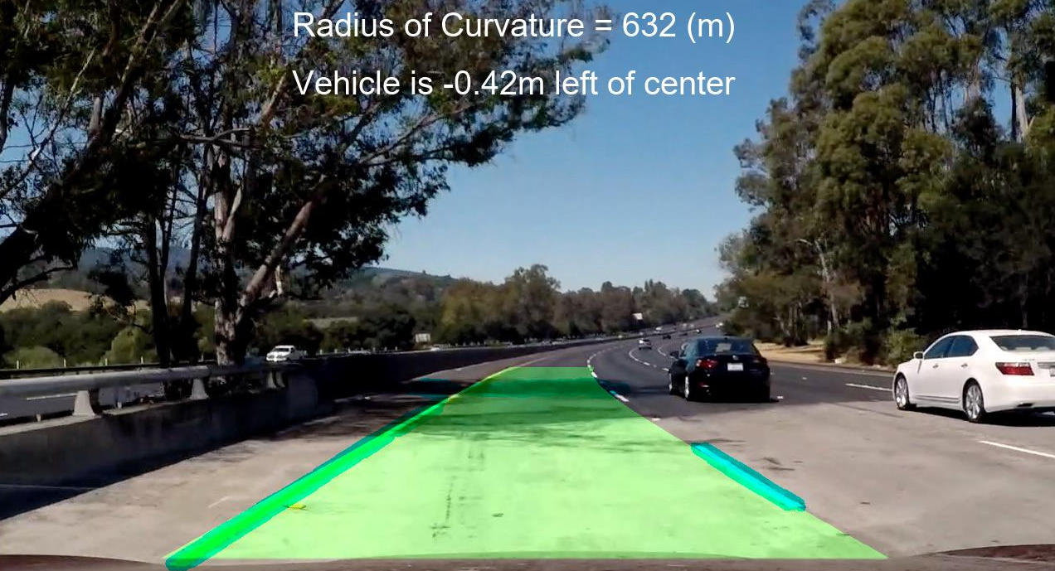

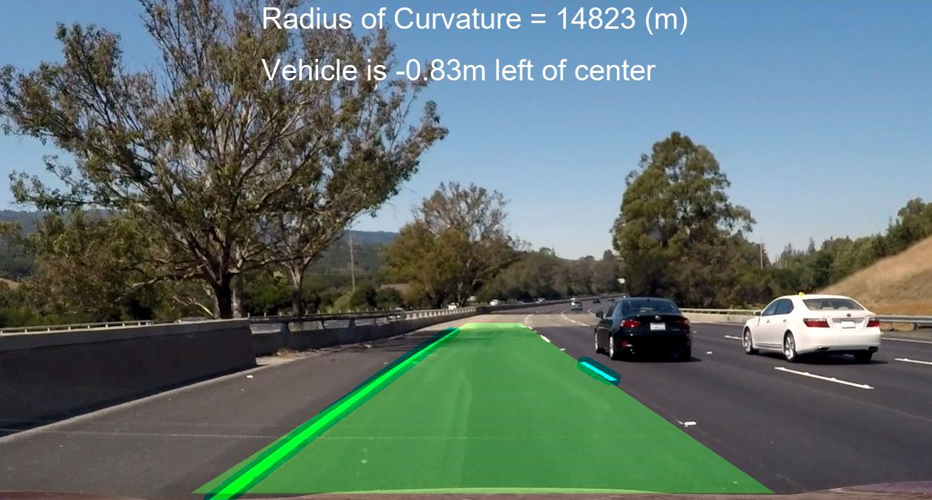

## project_video

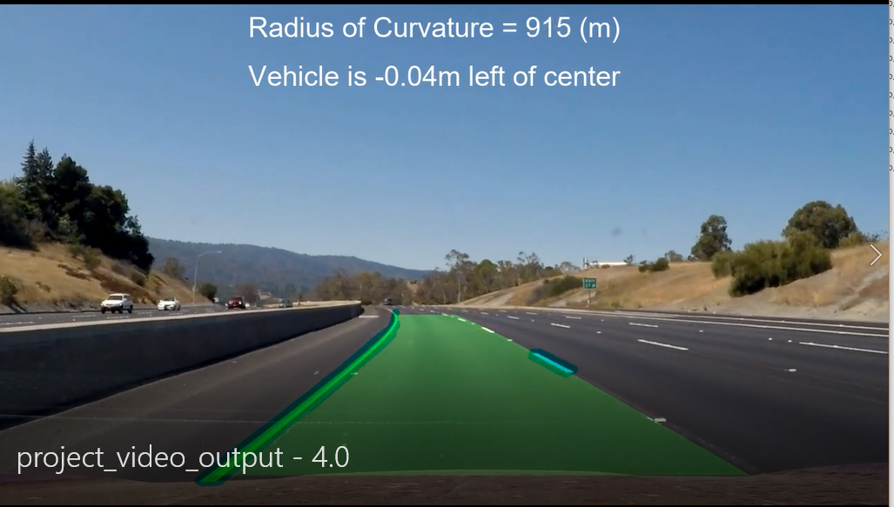

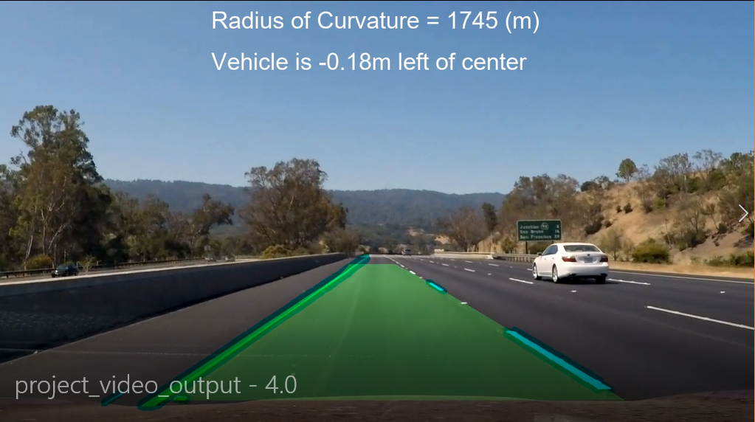

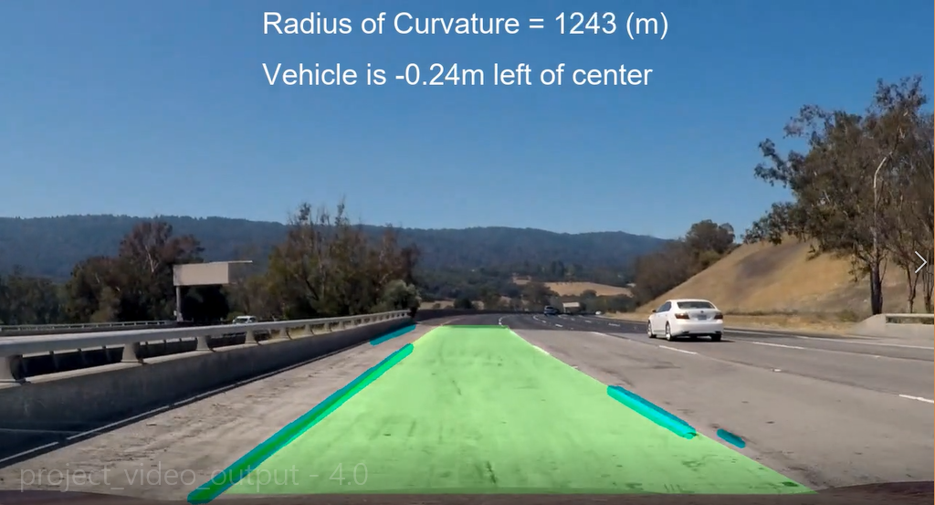

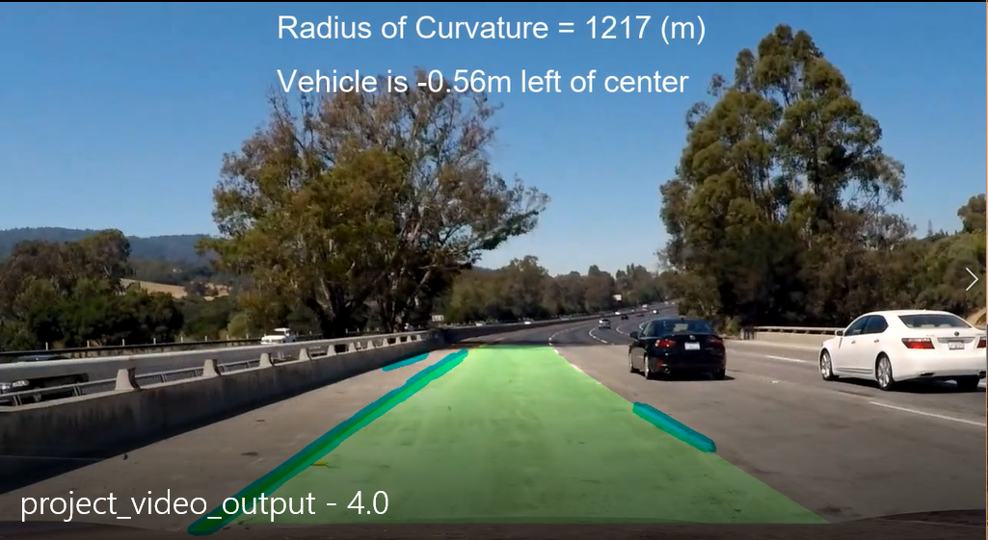

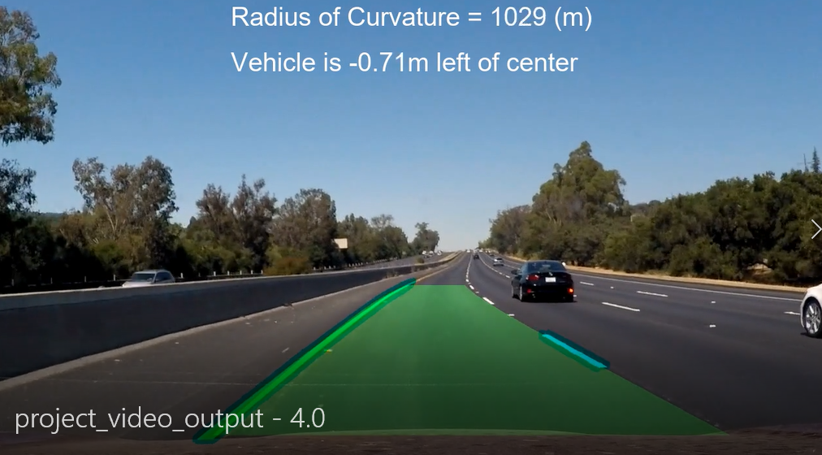

## challenge_video

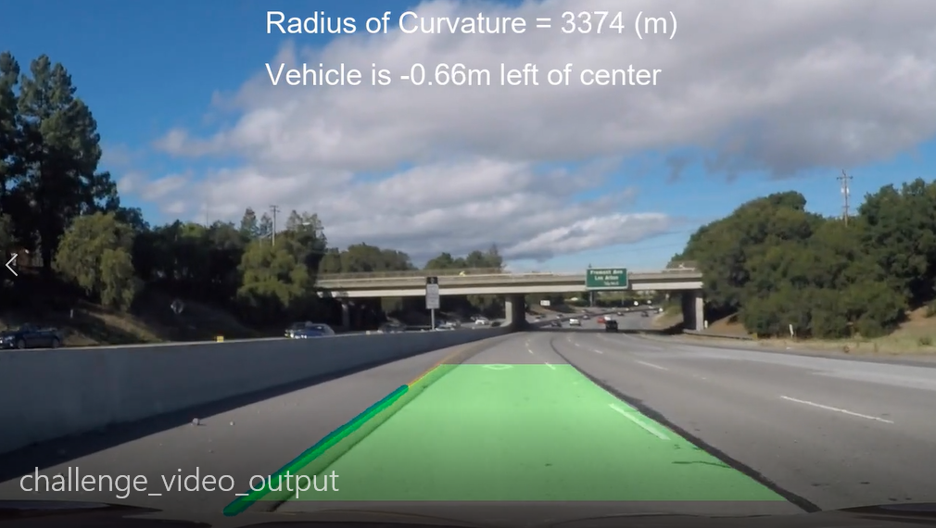

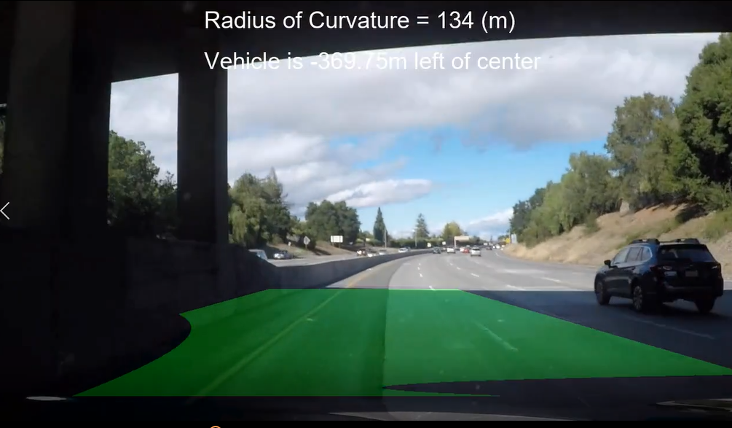

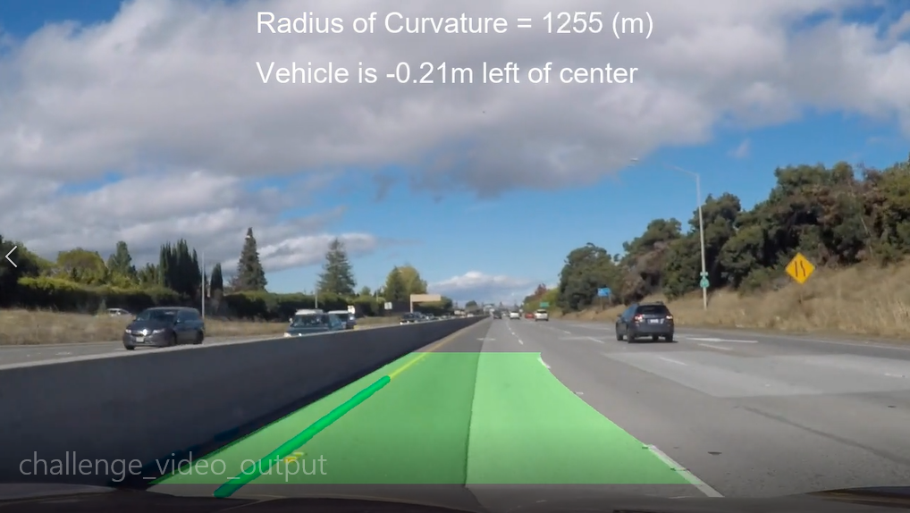

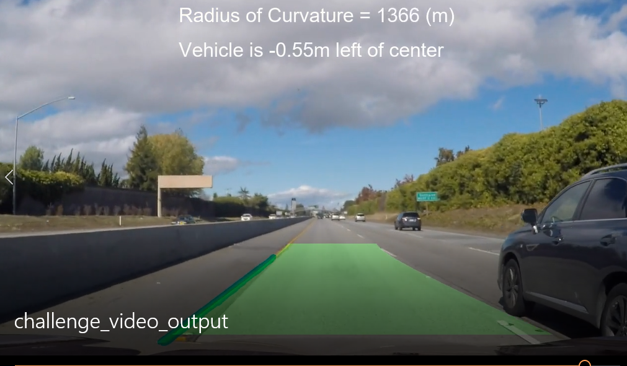

## harder_challenge_video

